114 Copper Way • P.O. box 755 • Port Hardy, BC V0N 2P0
Phone: (250) 230-4051
EMAIL: calvinhunt@telus.net
web site: www.calvinhunt.com

Calvin A. Hunt, RCA, BC Aboriginal Achievement Award
Artist Statement

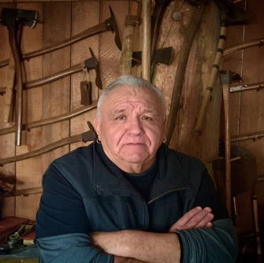
Chief Tłasutiwalis, Kwagu'ł, Fort Rupert
Hereditary Chief Nas’a̱m’yus, Mowachaht,
Friendly Cove

Coming from a long line of illustrious line of Chiefs and Kwagu’ł artists, becoming a skilled woodcarver means more than the artistic skill sets of carving; it is also about learning in the most holistic sense all aspects of Kwagu’ł culture, values, language, practices, song and dance. This work is fluid and informs everything that I create.

Life is a cycle of continuous learning and growth, and it is that which I incorporate into my artwork. I am aware that fine traditional Northwest Coast art constantly changes. I have always worked within the elements of traditional southern Kwakiutl art, and it has taken me years to broaden my artistic creativity due to my deep traditional artwork. However, I enjoy expanding and stretching the traditional Kwagu’ł art elements.

My artwork crosses the continuum of history and the present. I am grateful for the numerous opportunities I have had sharing our culture with the world, and I feel very fortunate to have the capacity to pass on our teachings. Most importantly, it is a way for us to teach our children, our “Kwala’yu”, (you are my reason for living) by providing a creative, inspiring environment that generates knowledge of their crests, legends, songs, and dances, giving them a sound foundation to their identity.

As I work within the traditional Kwagu’ł style, I am reminded of the diversity, spirituality, transformation and meaning of our Kwakwaka’wakw culture. I most enjoy working with western red cedar and am particularly interested in carving poles. When I create these monumental sculptural pieces, I begin by envisioning who the pole is for, who or what it will stand for, and where it will stand. There are certain elements that represent the unifying symbolism of various animals and legends which I follow through the knowledge and teachings of my Gigame’ (Chiefs), Elders and artists.

